Ulverston Victoria High School’s Design and Technology Department
Celebrates Generous Grant from Unite
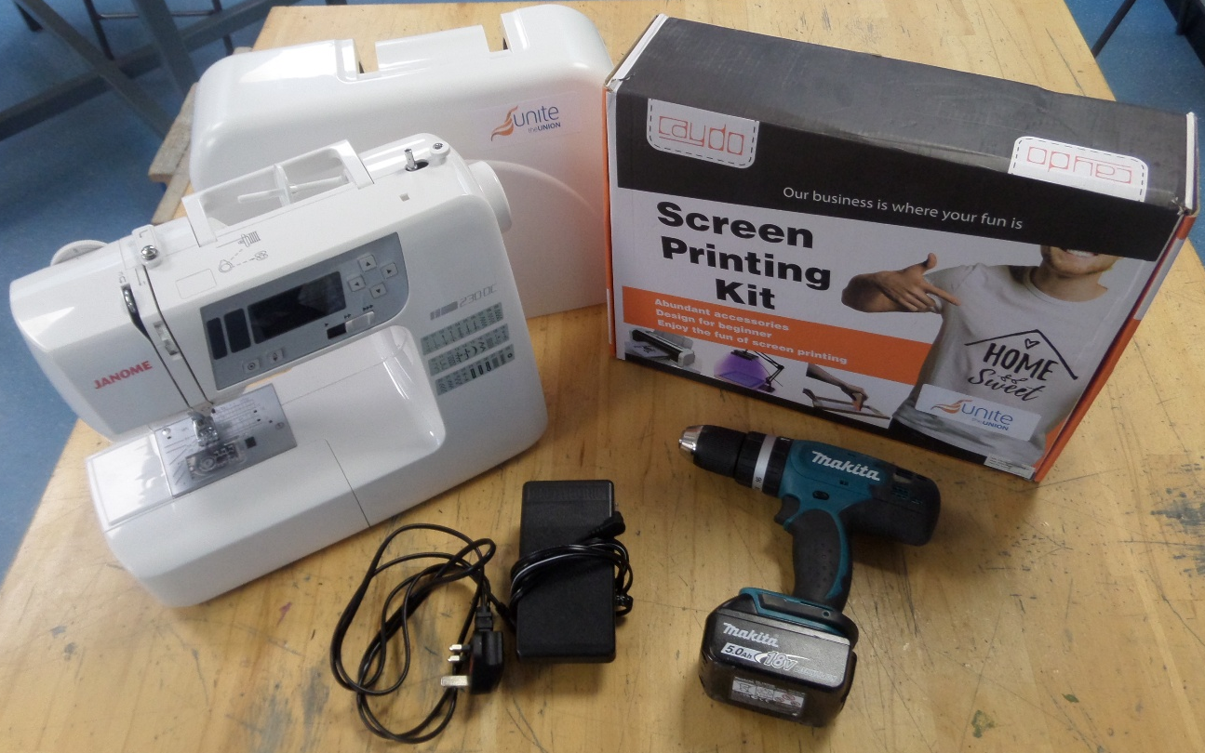

UVHS’s Design and Technology department has been delighted to receive a generous grant from The UNITE NW/0065 Barrow Manual Branch. The grant has been used to purchase new equipment which has supported Year 11 GCSE and Year 13 A-Level pupils.

Visitors from Unite, David Stowell (Chairman) and Stuart Klosinski (Secretary),
asked year 11 D&T pupils for their thoughts about what equipment they felt was missing from the department or needed to be upgraded. They also toured the workshops, spoke to staff and technicians, joined lessons and discussed career opportunities available to pupils in the local industry. Following their visit, UVHS made an application to Unite for a selection of new equipment suggested by Design and Technology pupils.

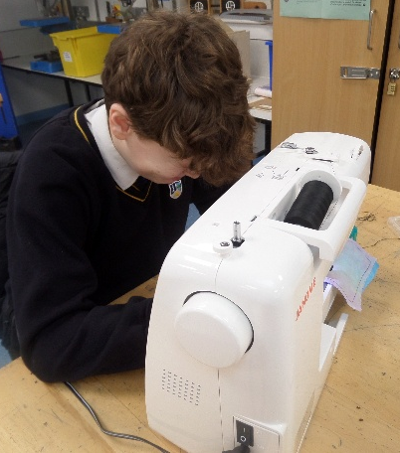
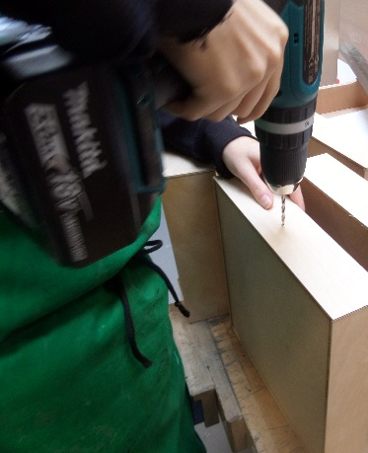
After a successful application, the grant has been used to purchase two new digital sewing machines and replaced 4 drills.

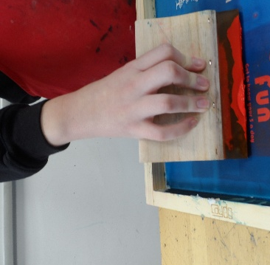
In addition to this equipment, the department was also able to purchase and try new silk-screen printing equipment, which is brand new to the department, but a technique studied in theory lessons. This opened opportunities for pupils to try new design and manufacturing techniques not used before in the department and gain a better understanding of industrial techniques.

The Design and Technology department would like to thank Unite for this very generous donation and the support given throughout the process to enable us to deliver an engaging curriculum using modern and practical skills. The equipment has enabled pupils to develop new skills, become confident in new knowledge and problem-solve through different manufacturing solutions.

After Unite’s visit, pupils have more awareness of the large amount of career opportunities in the local area using Design and Technology qualifications and skills. The equipment purchased through Unite’s grant will benefit future pupils to ensure every child is valued, supported and empowered to achieve their unique potential.

